# Advanced Software Engineering

## Assignment3

## WCF Restful service & Mash up

Student Details:

Sivakumar Pothala

16148142

Computer Science

# Restful service

Installing IIS Server

1. Open Manager window

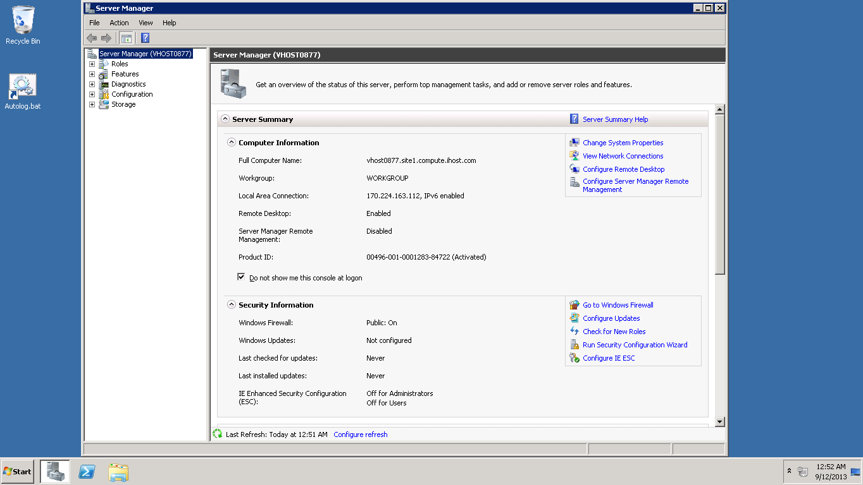

1. Adding roles

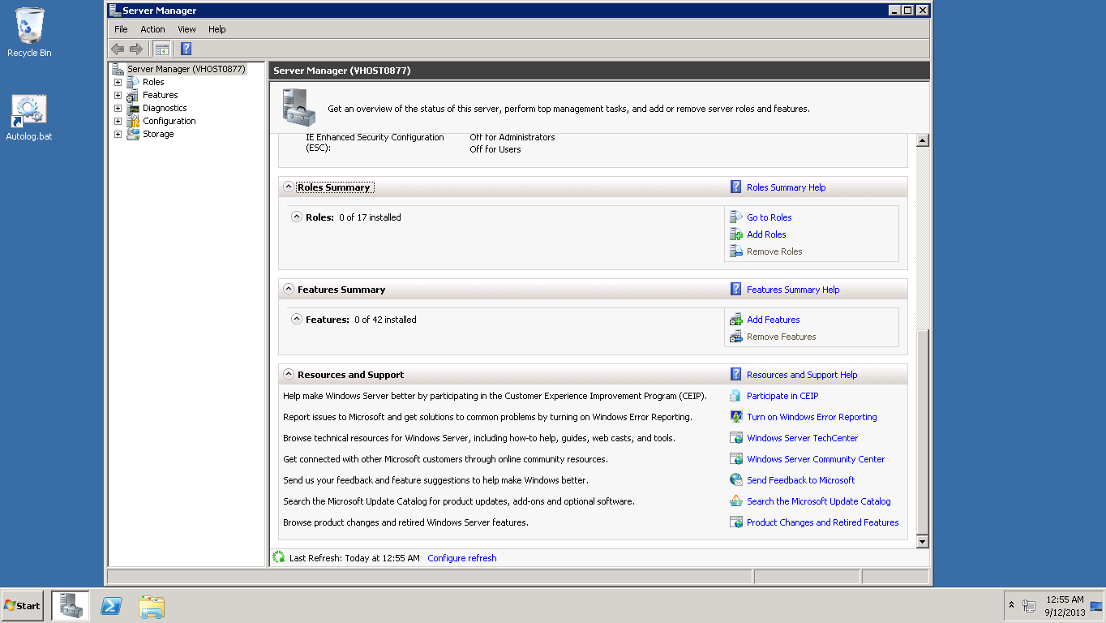

1. Selecting server role Web Server (IIS)

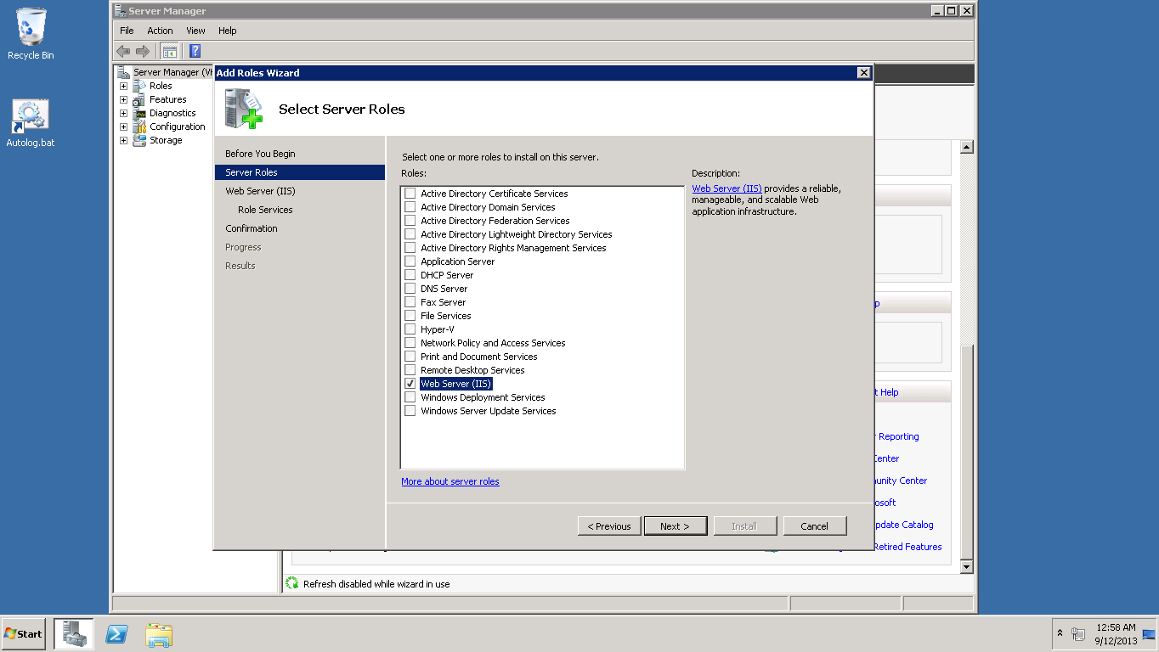

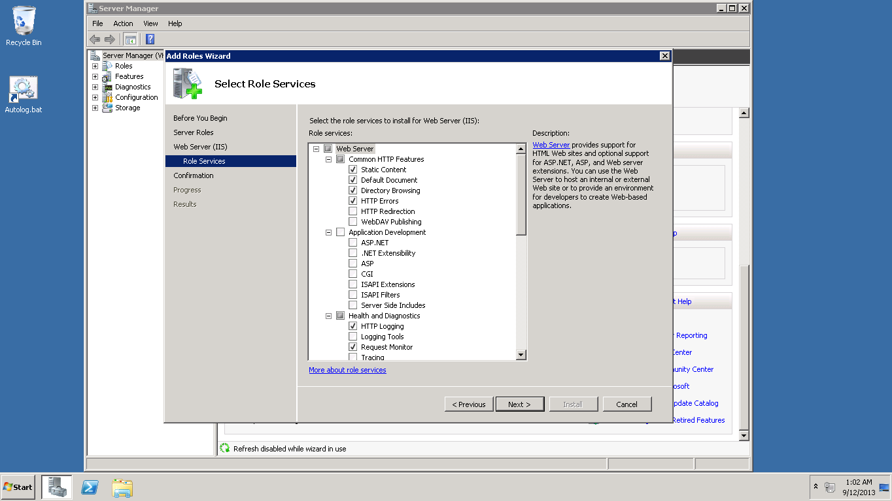

1. Installation Process

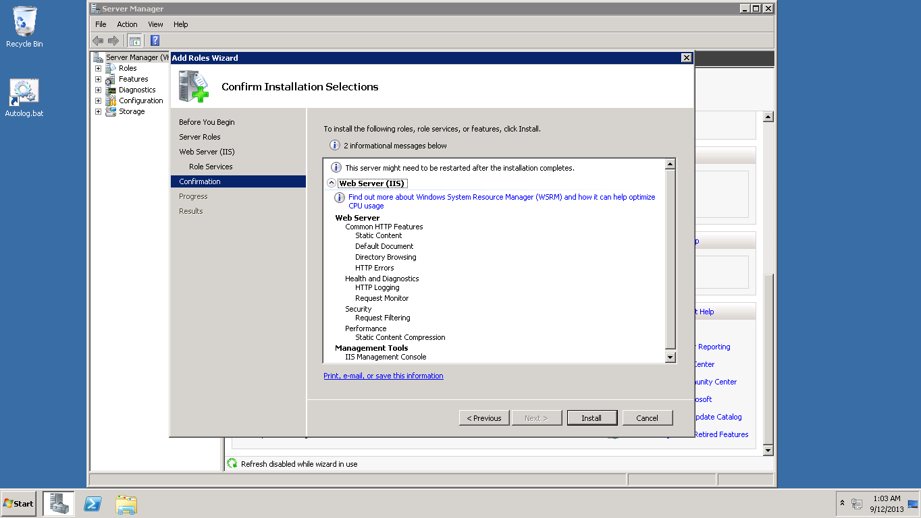

1. Installation successful

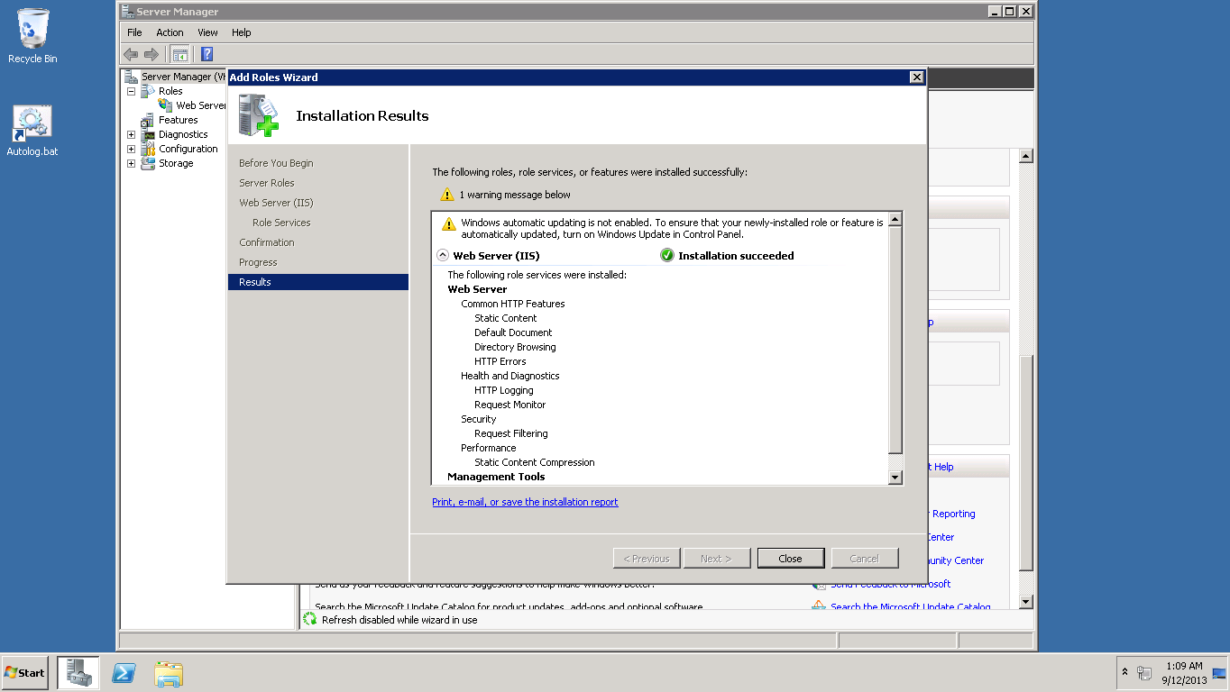

1. View by small icons

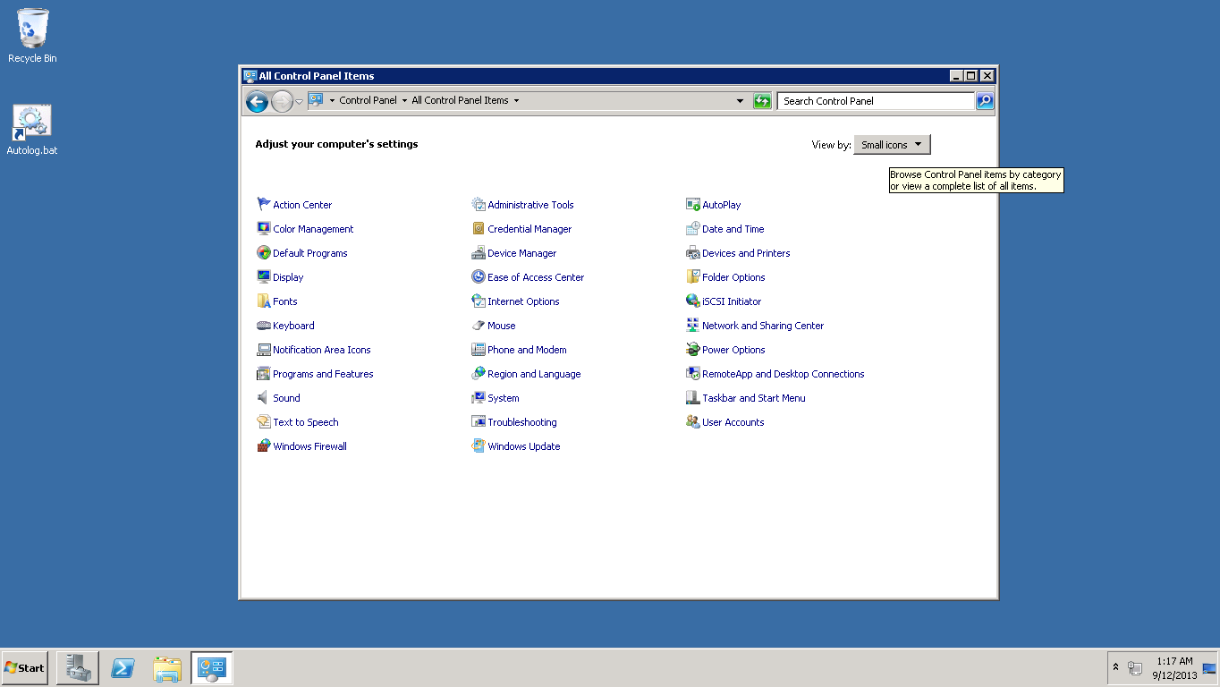

1. Setting up Windows Firewall

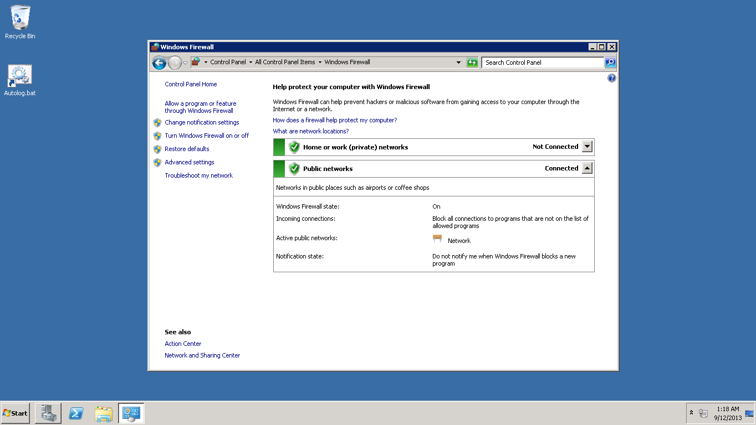

1. Firewall has been set to World wide web Services (HTTP)

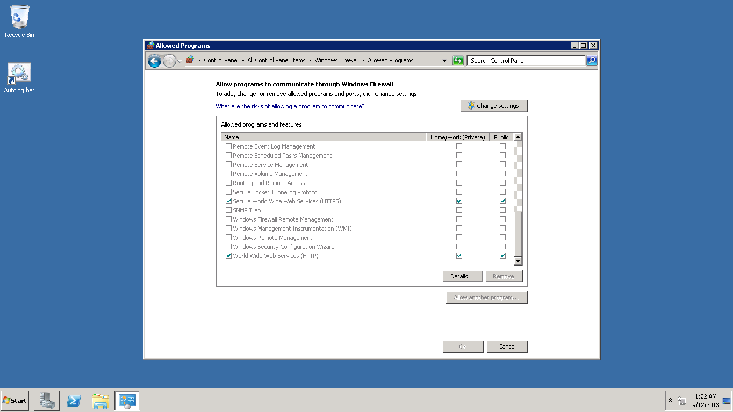

1. Changing Application host Configuration

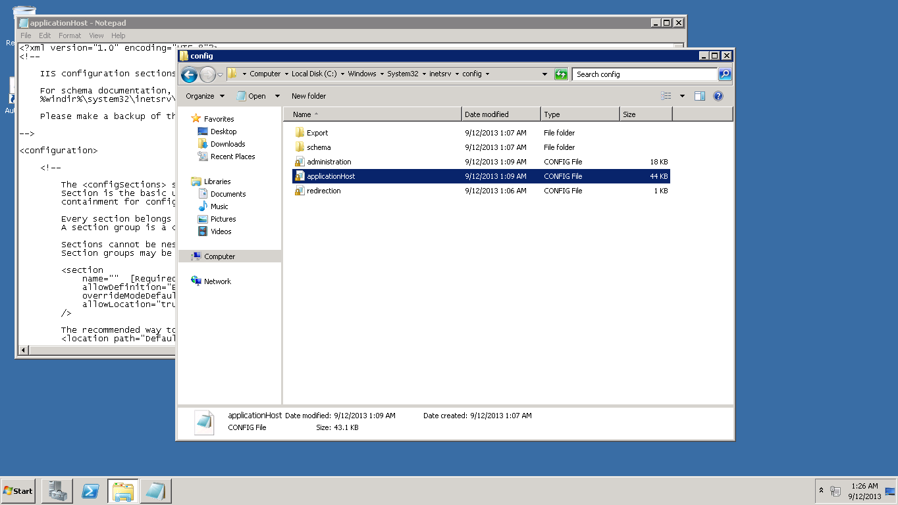

1. Application host opened in the notepad

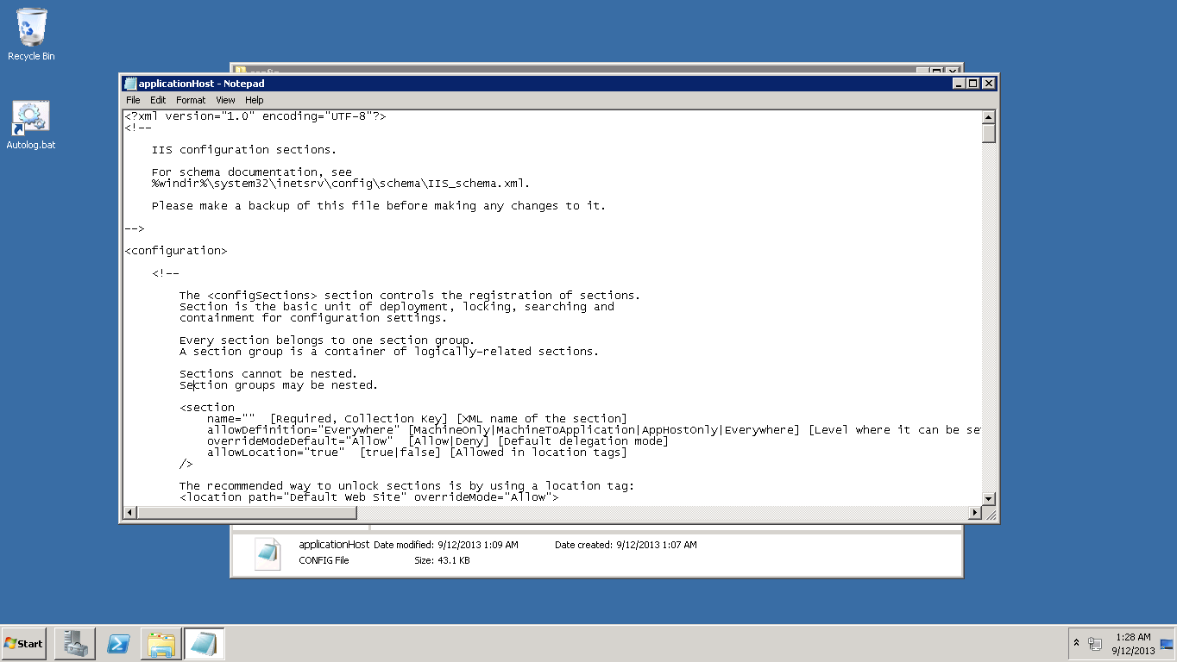

1. Changing override permissions for handlers and modules

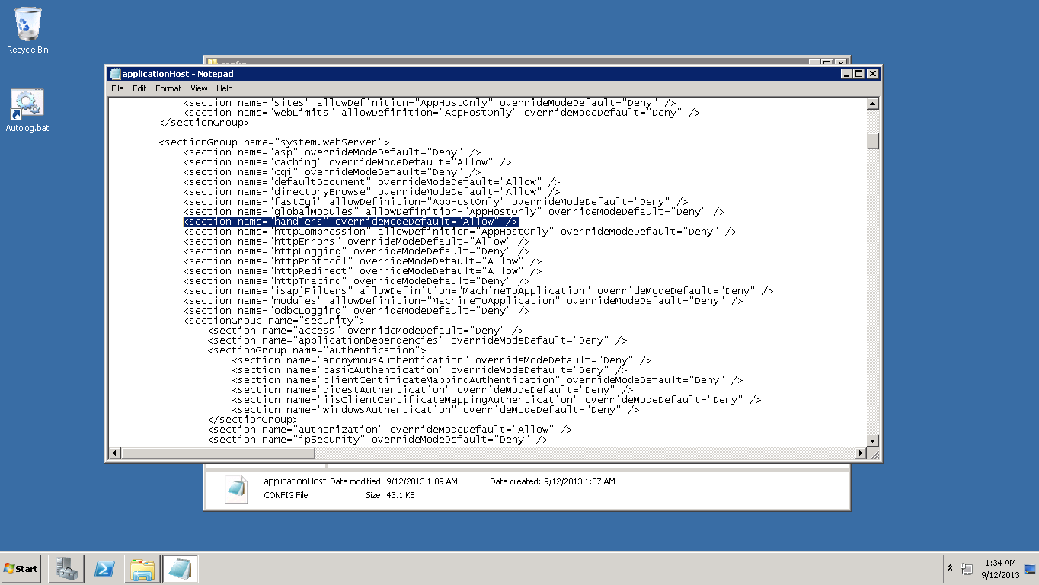

1. Selecting Features

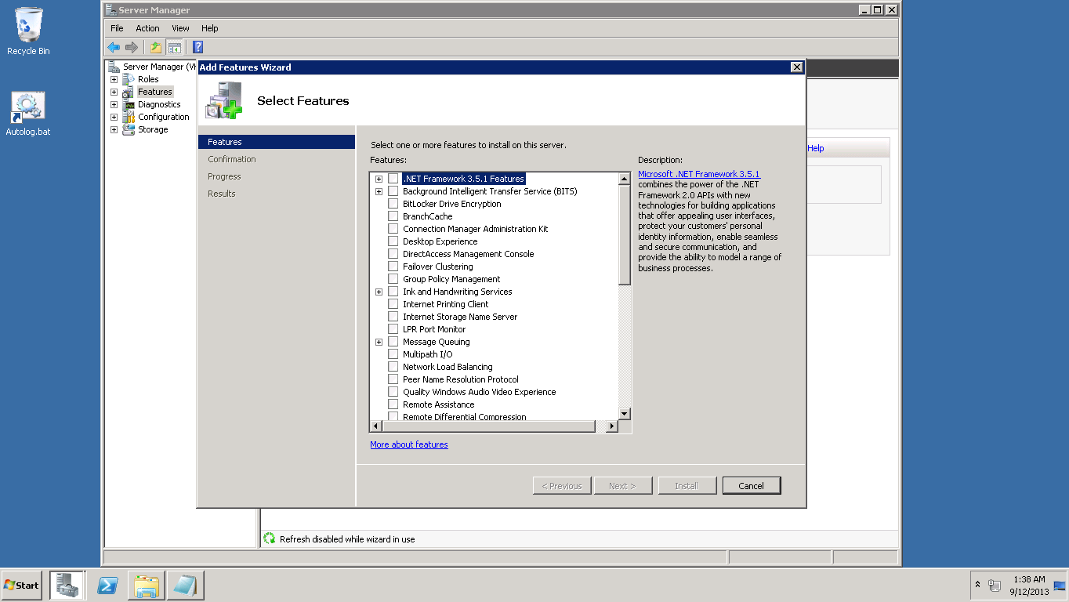

1. Adding .NET Framework 3.5.1 Features

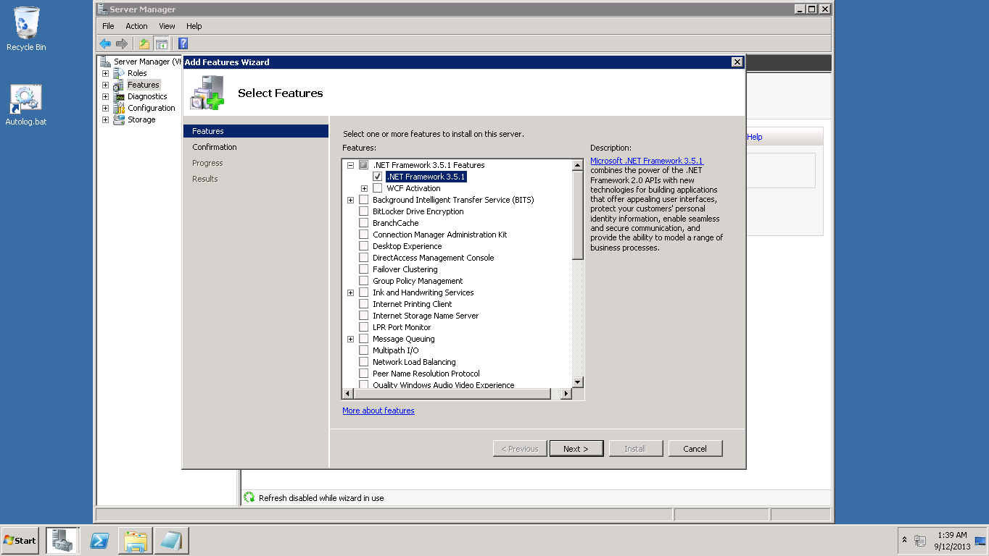

1. .NET Framework Installation successful

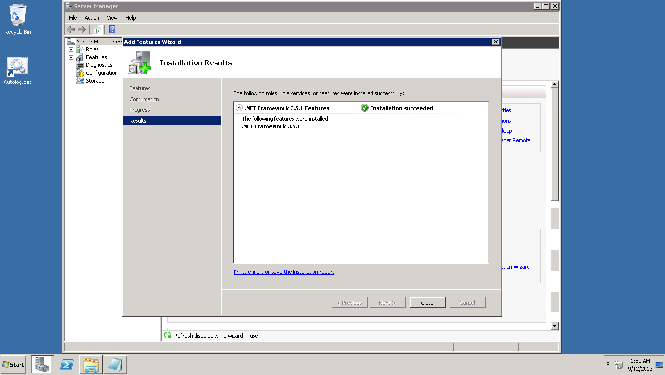

1. Windows Power shell run as administrator

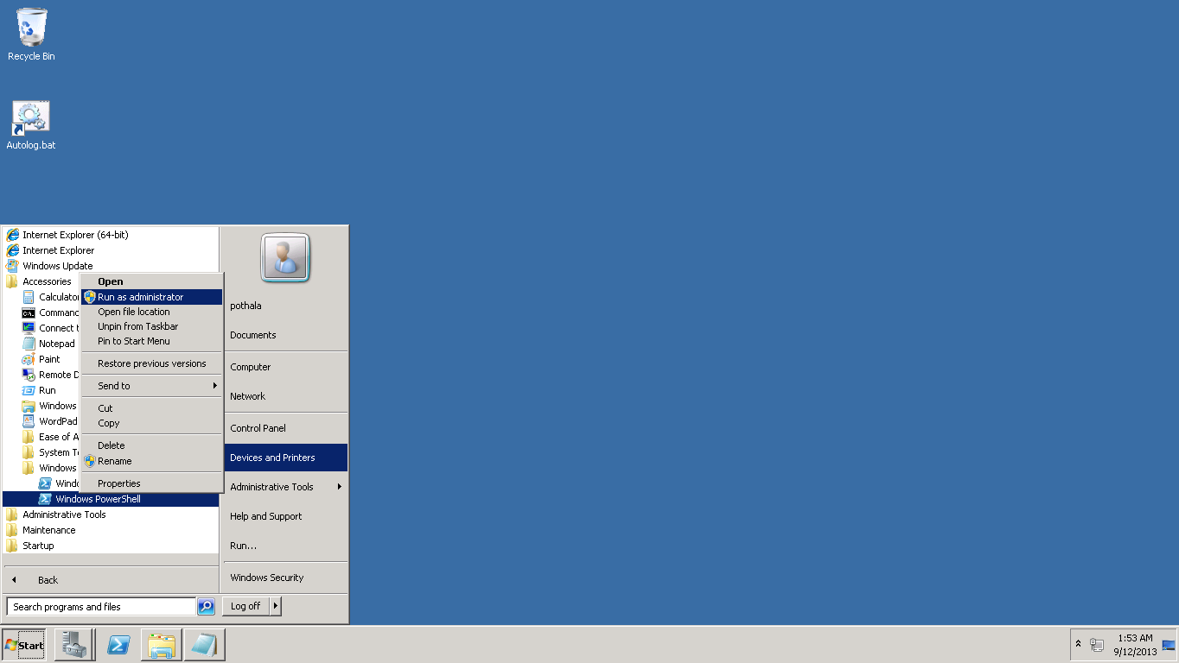

1. Added commands in power shell

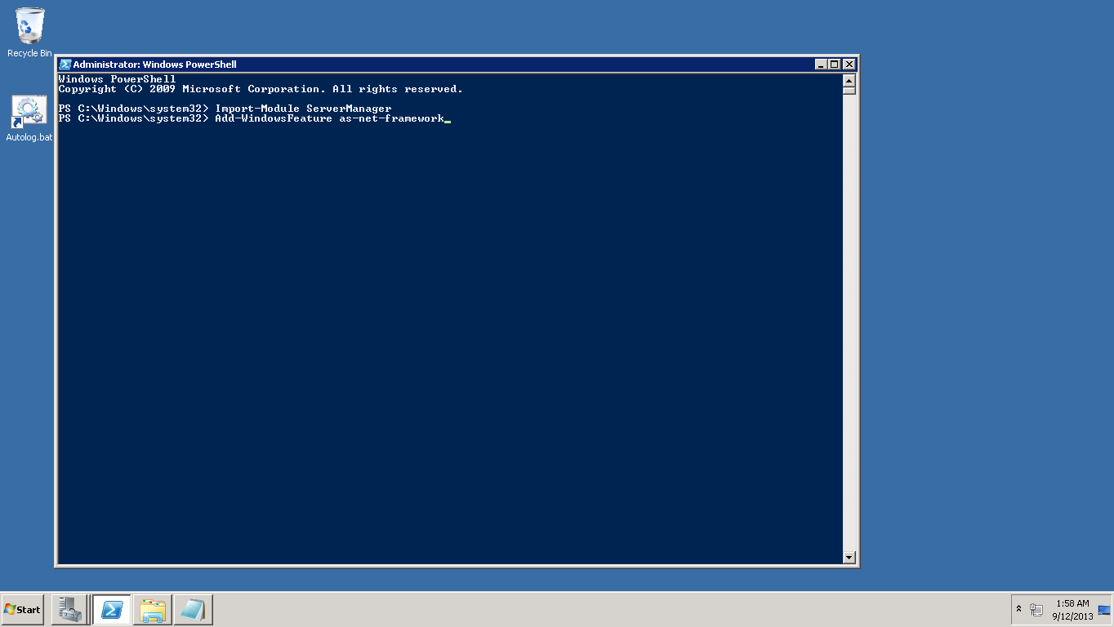

1. Shows successful run status

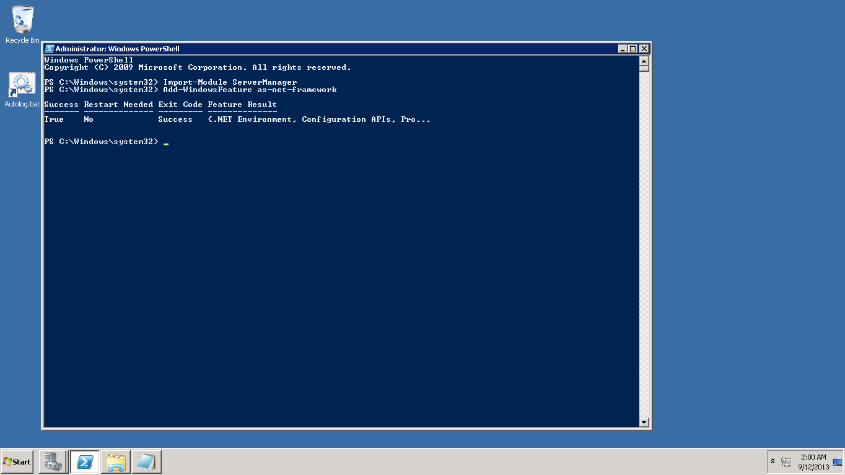

1. Installing Microsoft Web Installer 4.6

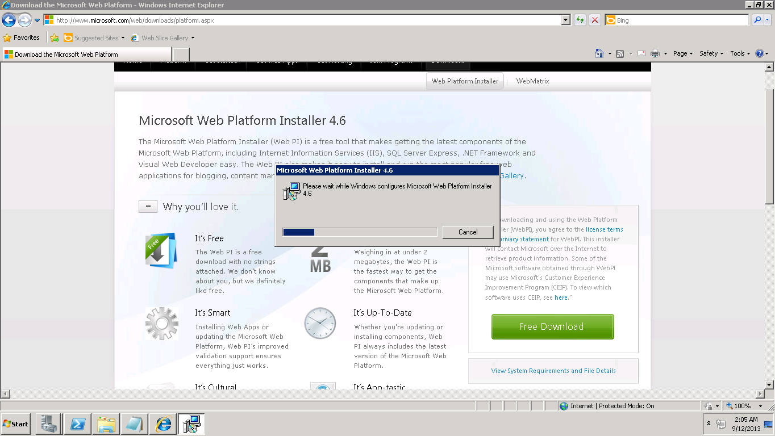

1. Adding IIS Recommended Configuration

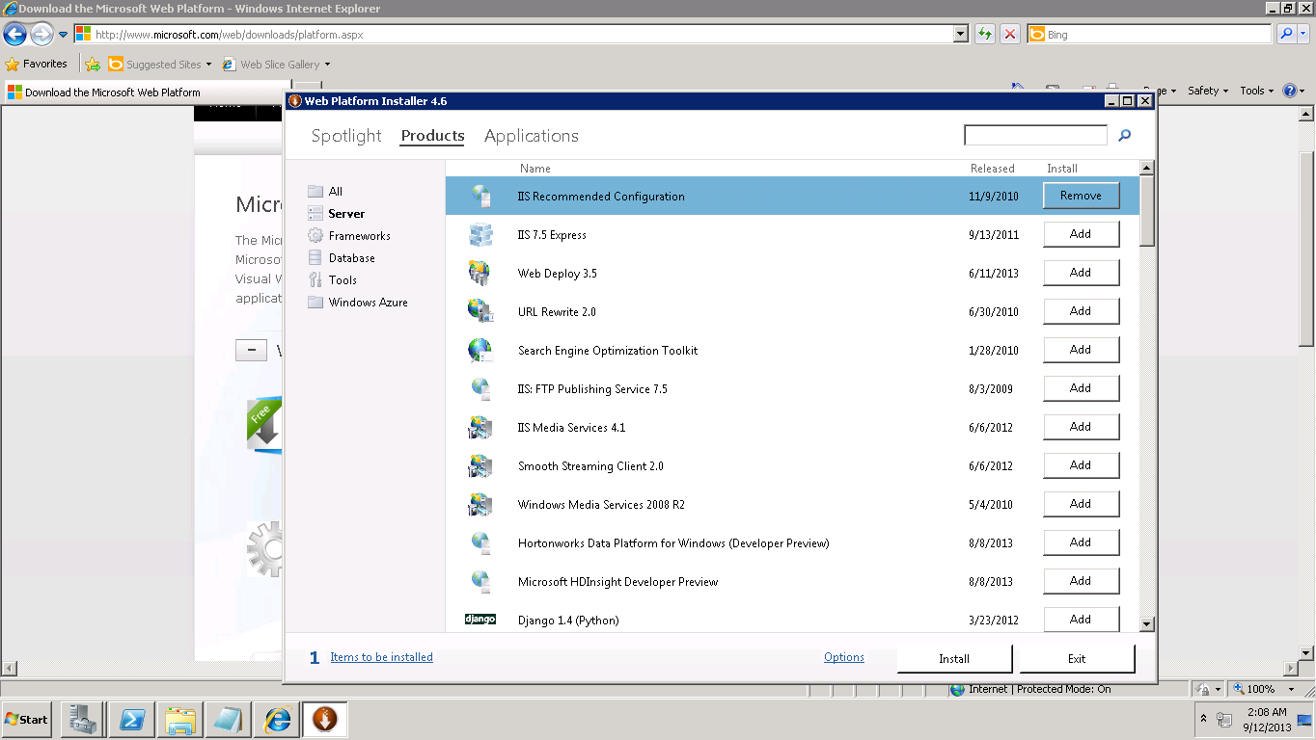

1. Added Visual studio and .NET Framework 4.5

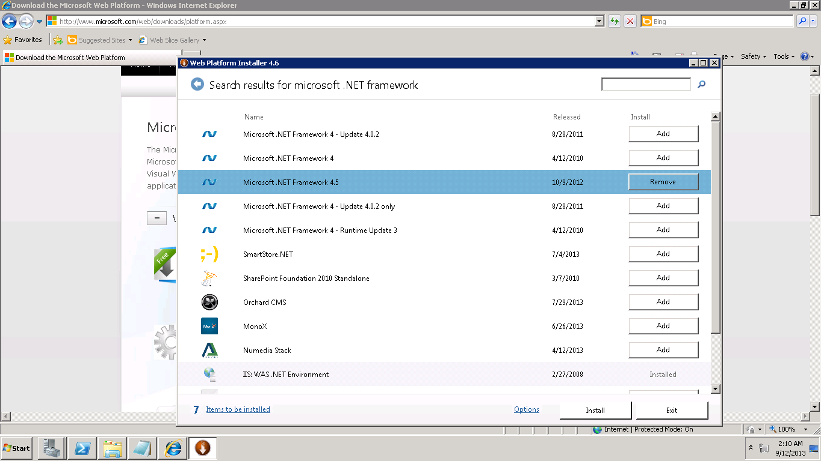

1. Installation Successful

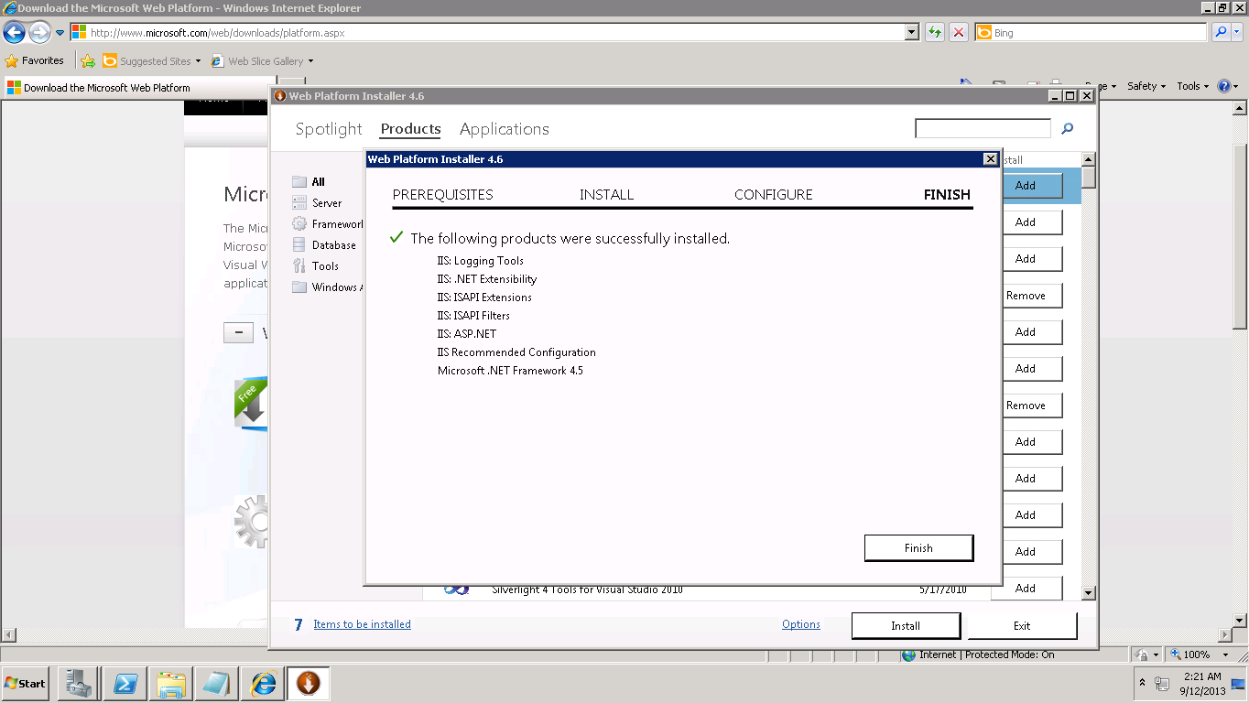

1. Converting WcfService1 to Application

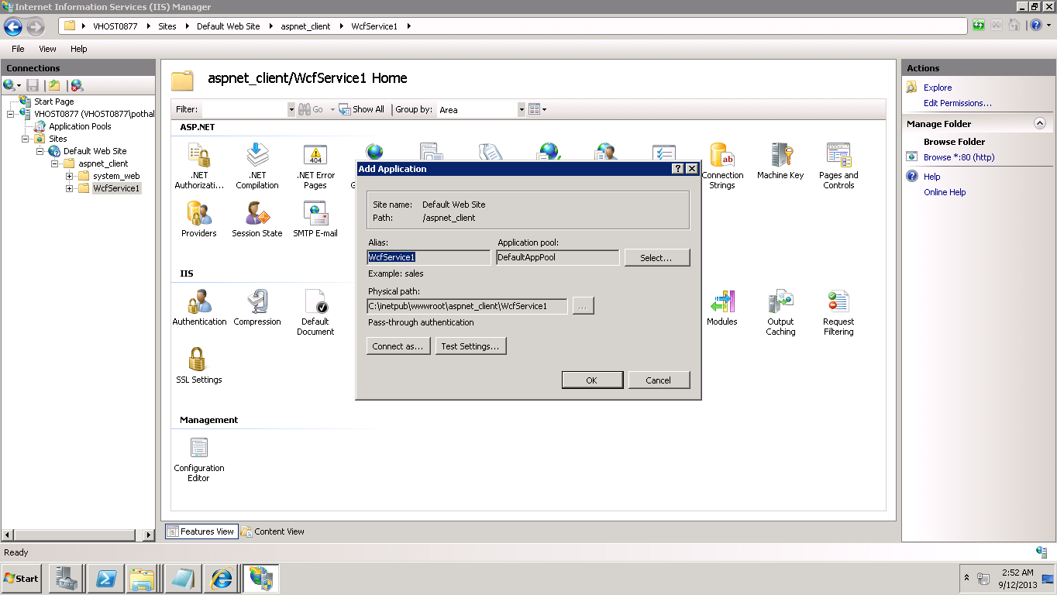

1. Content view of Service1

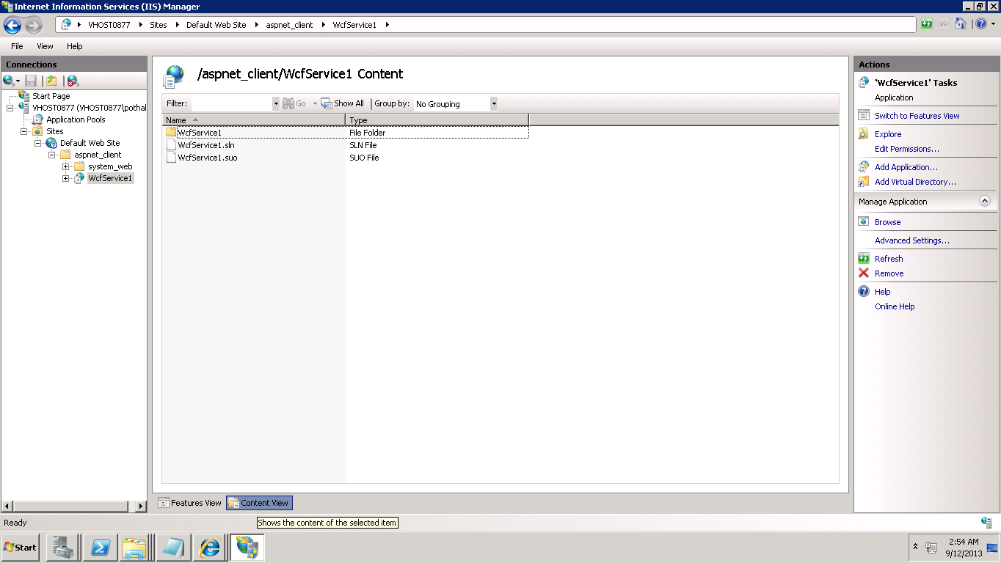

1. Adding Full control permissions to "IIS_IUSRS" group.

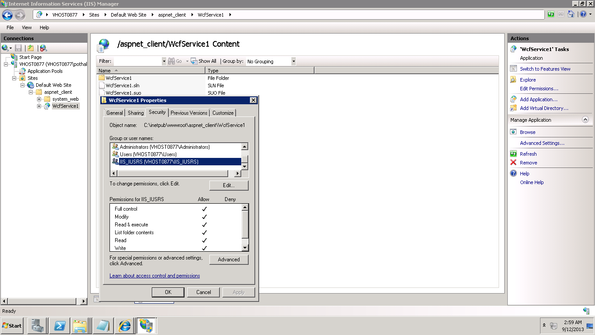

1. Changing Application pool to ASP .NET 4.0

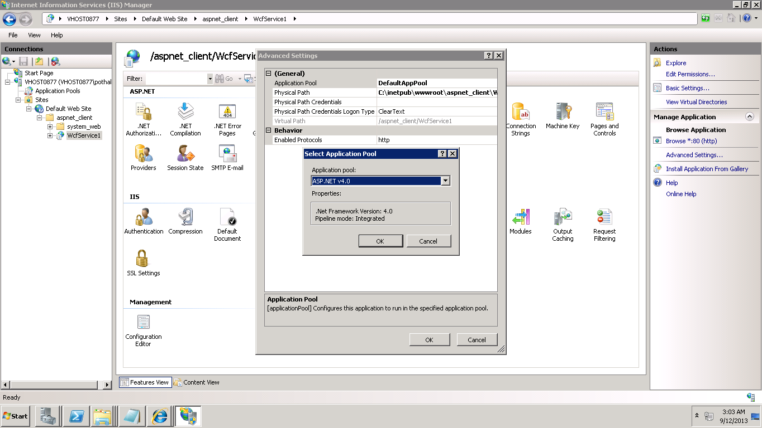

1. After running this service it returned a JSON file

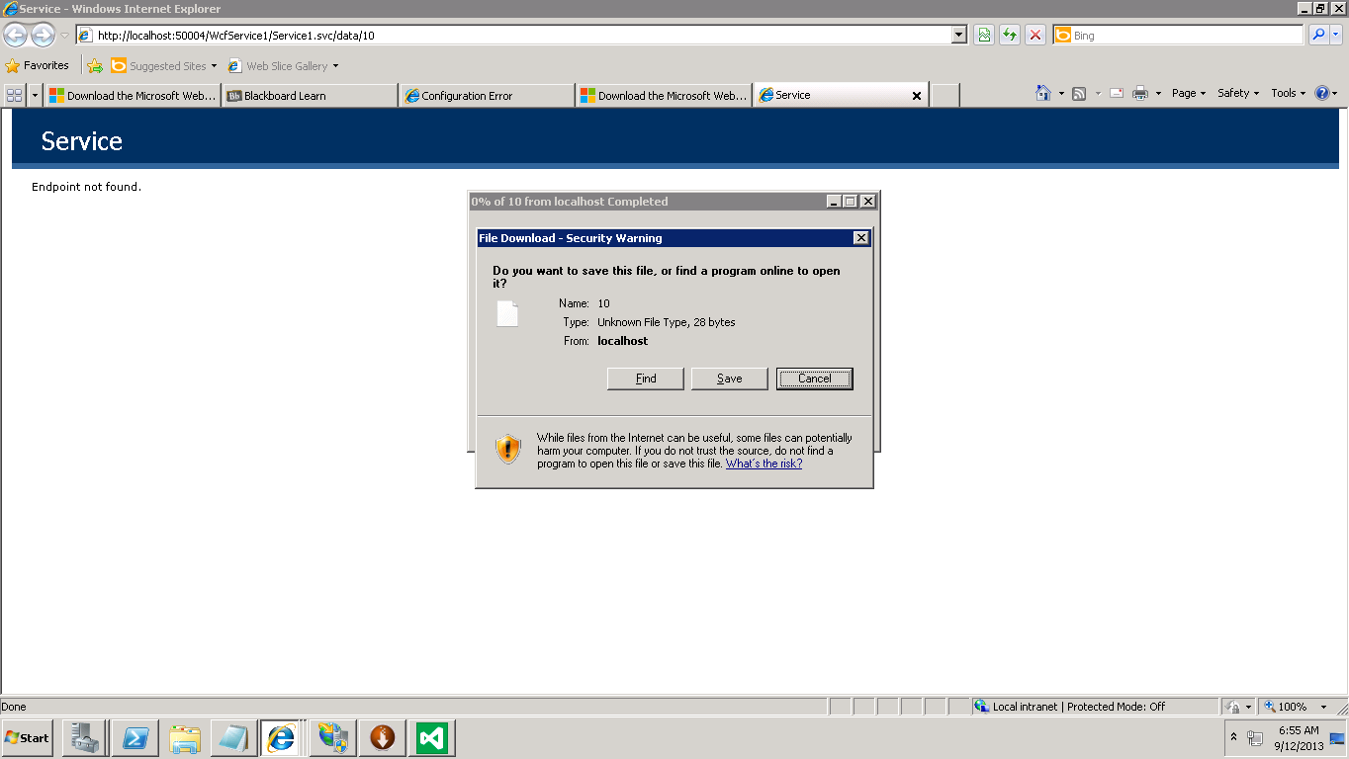

1. See Output file data

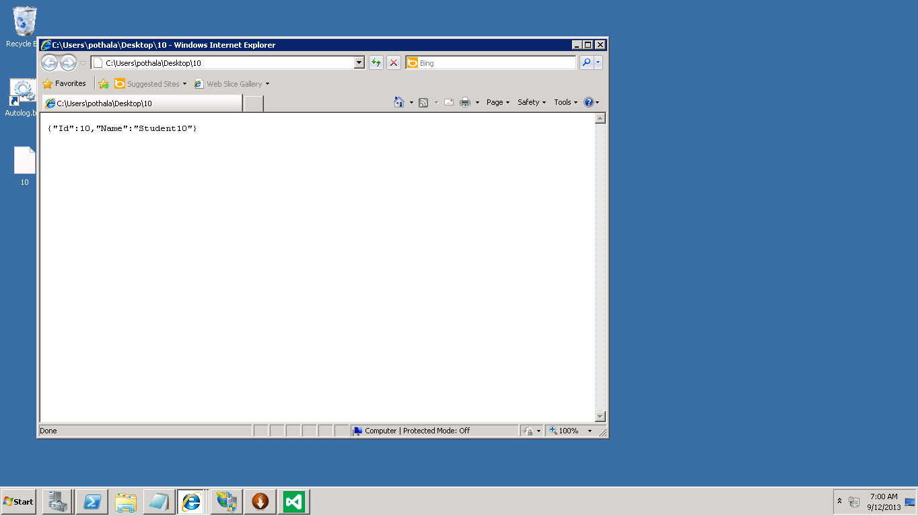

We can see the same output by replacing Local Host with Instance Hostname.

# Mashup

See output: <http://jsfiddle.net/shivapothala/BL6Rs/>

* Mashup by Google Maps and Google Spreadsheets
* Three maps Displayed US Senate Map, US House of Representatives Map and Obama Video Map
* Twitter option added to follow daily tweets
* Each Map has markers to denote corresponding locations
* YouTube videos included on Obama Video Map

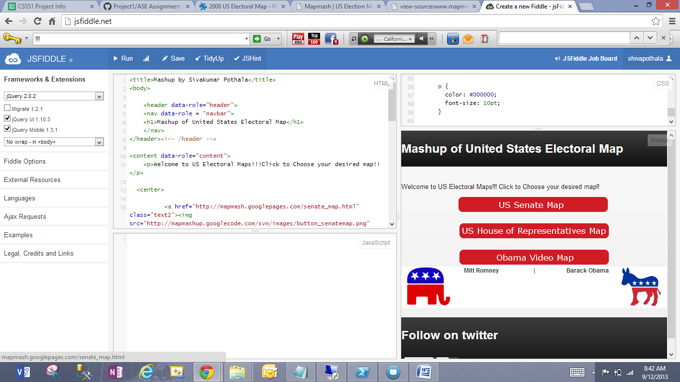

* Chosen US Senators Map
* Shows senator locations with markers

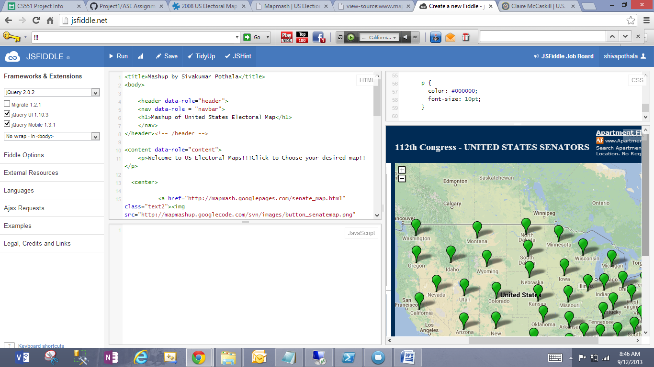

* Click on marker to select senator

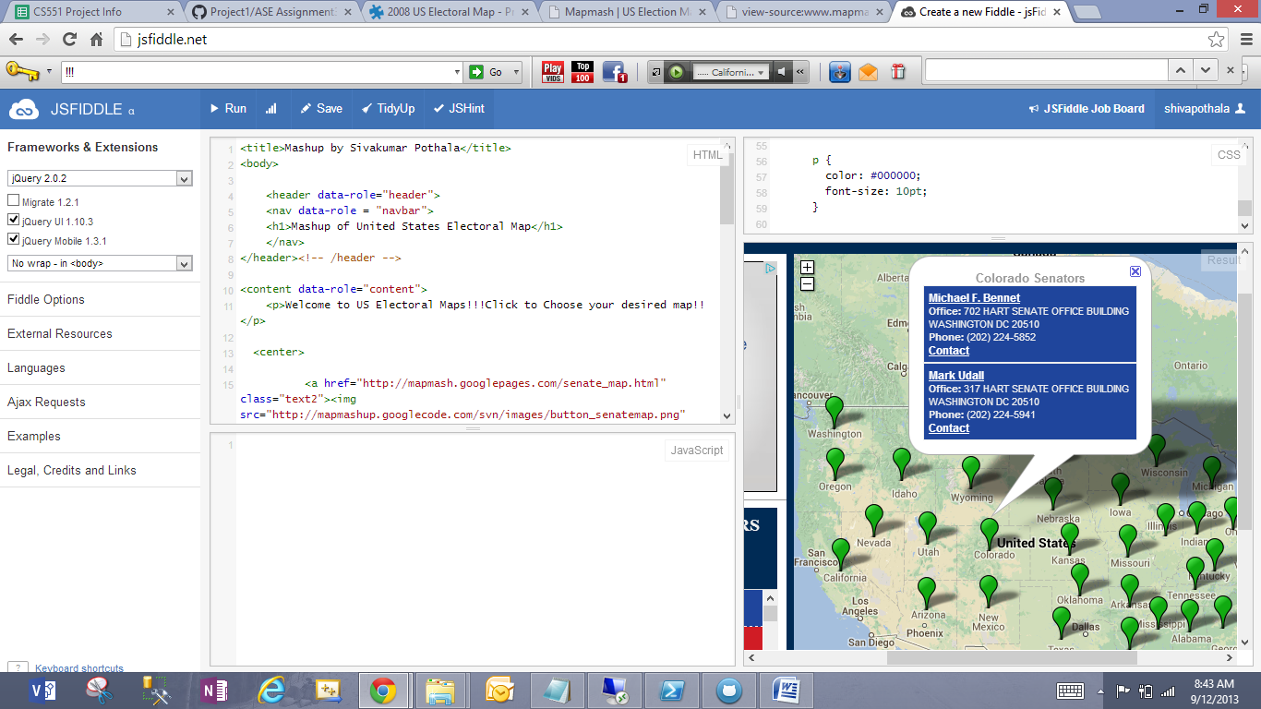

* Select senator from drop down list placed on left side
* It will take you to senator web page

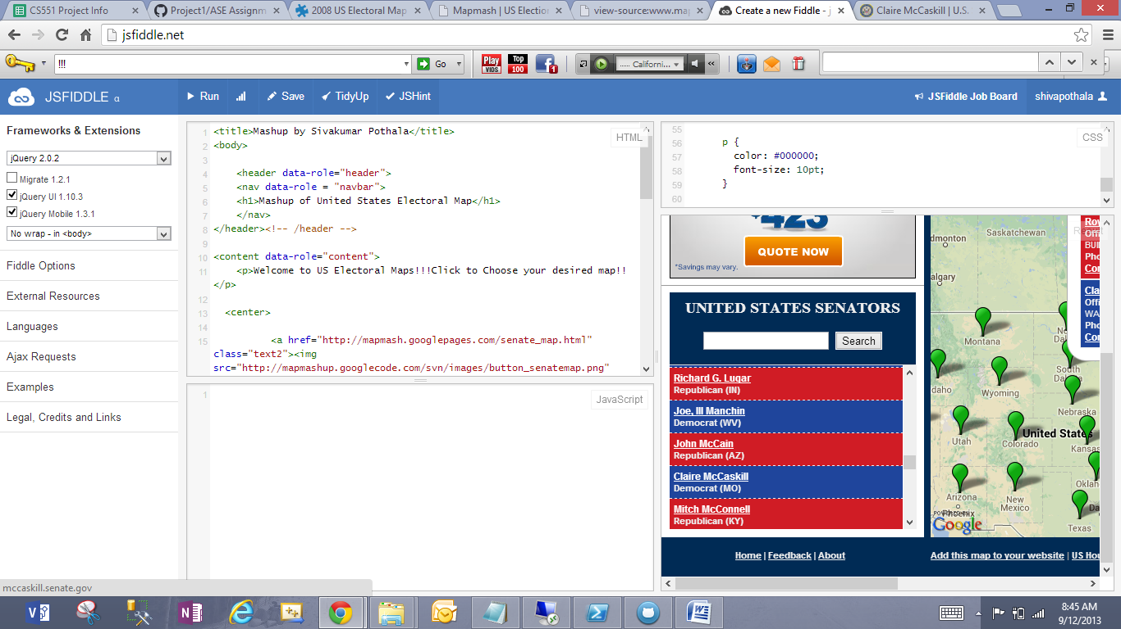

* Senator webpage displayed

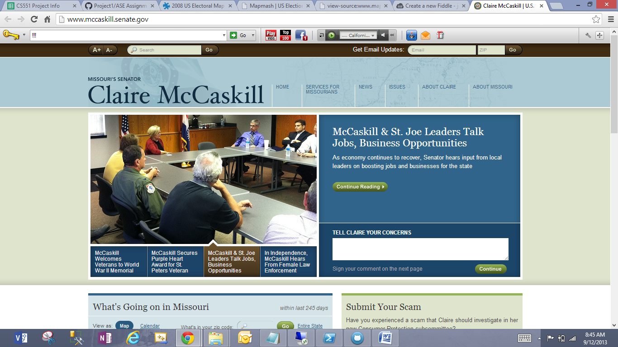

* **Second Map: US House of Representatives**
* Markers setup for each representative, click to select anyone

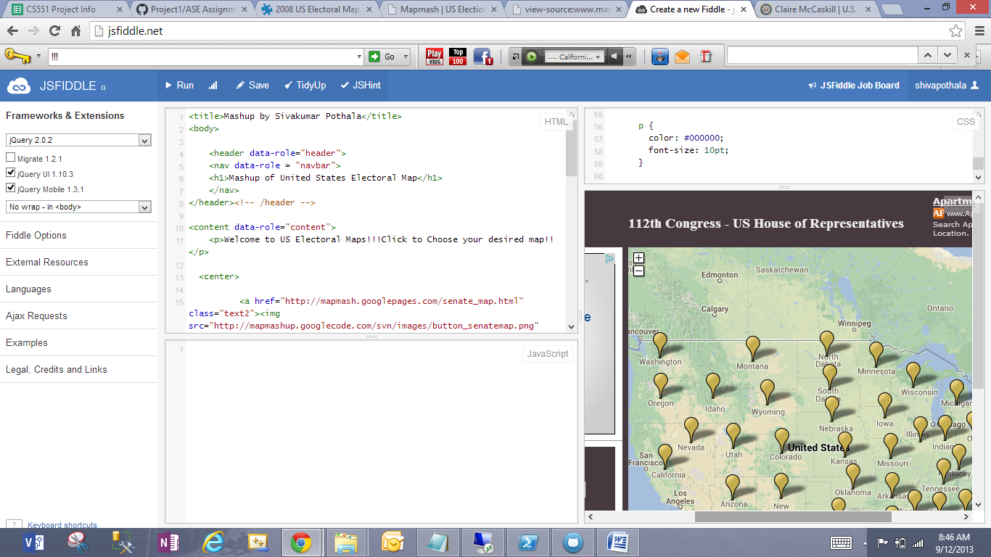

* **Third Map: Obama Video Map**

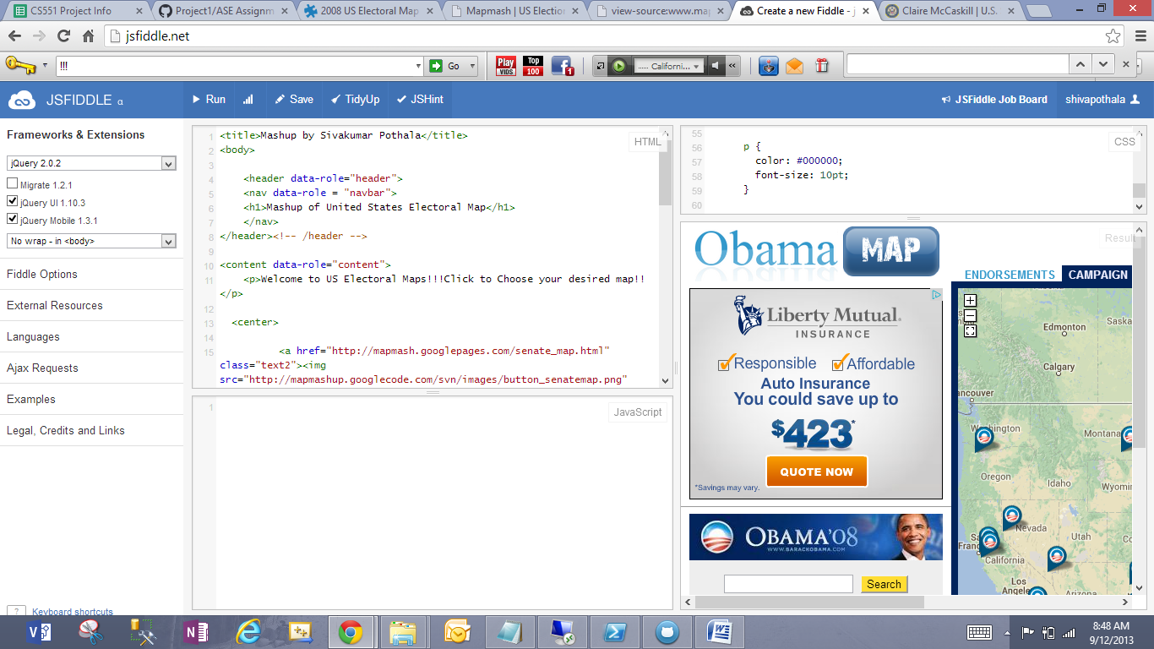

* Click on any marker to select Obama speech shown on YouTube
* IOWA victory speech displayed on YouTube when user clicks on Iowa

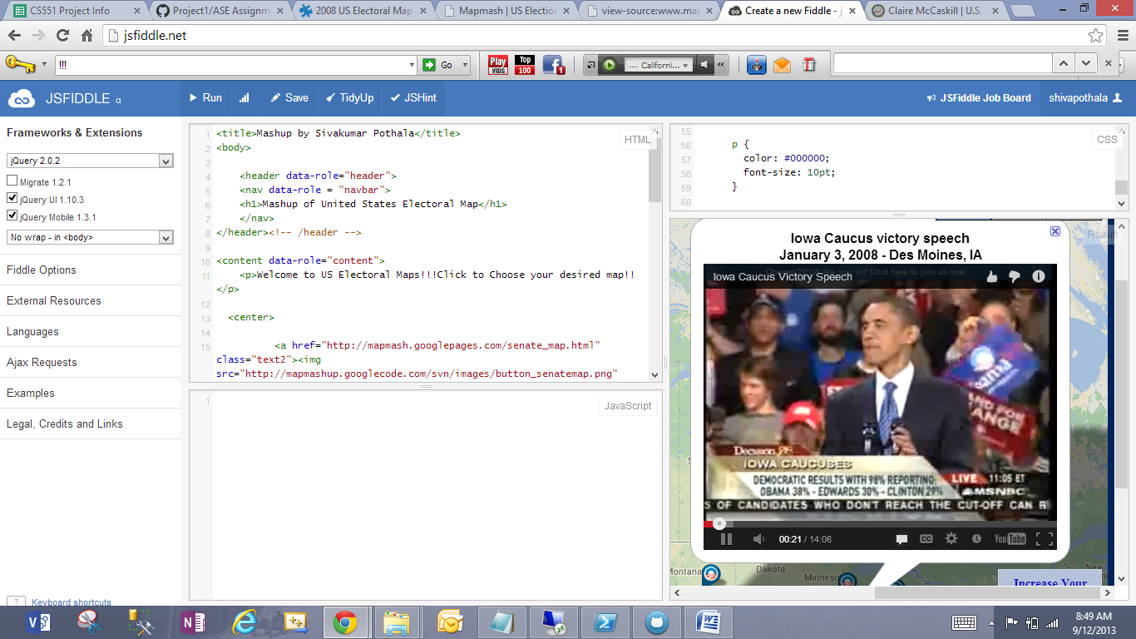

**References:**

<http://www.programmableweb.com/mashup/2008-us-electoral-map>

<http://www.programmableweb.com/>

**Source Code: HTML**

<title>Mashup by Sivakumar Pothala</title>

<body>

<header data-role="header">

<nav data-role = "navbar">

<h1>Mashup of United States Electoral Map</h1>

</nav>

</header><!-- /header -->

<content data-role="content">

<p>Welcome to US Electoral Maps!!!Click to Choose your desired map!!</p>

<center>

<a href="http://mapmash.googlepages.com/senate_map.html" class="text2"><img src="http://mapmashup.googlecode.com/svn/images/button_senatemap.png" border="0"alt="US Senate Map"></a>

<br>

<img src="blank.gif" width="1" height="8" border="0"><br>

<a href="http://mapmash.googlepages.com/houseofrep_map.html" class="text2"><img src="http://mapmashup.googlecode.com/svn/images/button_houseofrepmap.png" border="0"alt="US House of Representatives Map"></a><br>

<img src="blank.gif" width="1" height="8" border="0"><br>

<a href="http://mapmash.googlepages.com/obama_map.html" class="text2"><img src="http://mapmashup.googlecode.com/svn/images/button_obamamap.png" border="0"alt="Obama Campaign Map"></a>

</center>

<table style="width:100%; height:100%" width="100%" height="100%" align="center" border="0" cellspacing="0" cellpadding="0" bgcolor="#ffffff">

<tr>

<td width="20%" align="center" class="text2" rowspan="3" height="20"><span id="rlogo"><img src="http://mapmashup.googlecode.com/svn/images/rlogo.png" border="0"></span></td>

<td width="20%" align="center" class="text2"><b>Mitt Romney</b></td>

<td width="20%" align="center" class="text2">|</td>

<td width="20%" align="center" class="text2"><b>Barack Obama</b></td>

<td width="20%" align="center" class="text2" rowspan="3"><span id="dlogo"><img src="http://mapmashup.googlecode.com/svn/images/dlogo.png" border="0"></span></td>

</tr>

</table>

</content>

<footer data-role="footer">

<nav data-role = "navbar">

<h1>Follow on twitter</h1>

<a href="https://twitter.com/share" class="twitter-share-button">Tweet</a>

<script>!function(d,s,id){var js,fjs=d.getElementsByTagName(s)[0],p=/^http:/.test(d.location)?'http':'https';if(!d.getElementById(id)){js=d.createElement(s);js.id=id;js.src=p+'://platform.twitter.com/widgets.js';fjs.parentNode.insertBefore(js,fjs);}}(document, 'script', 'twitter-wjs');</script>

</nav>

</footer><!-- /footer -->

</body>

**Source code: CSS**

<style type="text/css">

body {

font-family: Arial, sans-serif;

margin: 0;

overflow: auto;

}

.text1 {

color: #999999;

font-size: 8pt;

}

.text2 {

color: #333333;

font-size: 9pt;

}

.text3 {

color: #ffffff;

font-size: 10pt;

text-decoration:none;

}

.text4 {

color: #999999;

font-family:Times;

font-size: 14pt;

}

.text5 {

color: #002b55;

font-size: 10pt;

text-decoration:none;

}

a {

color: #999999;

font-weight: bold;

font-size: 8pt;

}

.link{

text-decoration:underline;

color: #ffffff;

font-weight: bold;

font-size: 9pt;

}

.nolink{

color: #333333;

font-weight: bold;

font-size: 8pt;

}

p {

color: #000000;

font-size: 10pt;

}

</style>

**********************Thank You**************************************************